**MODELING AND VISUALIZATION OF THE RADIAL AND ANGULAR PARTS OF THE SCHRODINGER EQUATION**

* Project requirements and programming dependencies :

- python 3.11.3  
-scipy 1.12.0

-matplotlib 3.8.3

-numpy 1.26.4

-built in math library.

-IDE of choice: Visual Studio.

* Both raw and executable copies are available within the file.
* In order to minimize the dependency on imported libraries (which can cause performance issues on some machines), generalized and associated “Laguerre” and “Legendre” polynomials were programmed using the recursion method which had to be optimized to not exceed the maximum recursion depth set by default to be 994.
* Associated Legendre Polynomial [https://en.wikipedia.org/wiki/Associated_Legendre_polynomials#Recurrence_formula](https://en.wikipedia.org/wiki/Associated_Legendre_polynomials%23Recurrence_formula)
$$(l-m+1)P_{l+1}^{m}​(x)=(2l+1)xP_{l}^{m}​​(x)-(l+m)P_{l-1}^{m}​​(x)$$

$$=>P_{l}^{m}​(x)=\frac{(2l+1)xP_{l-1}^{m}​​(x)-(l+m)P_{l-2}^{m}​​(x)}{(l-m+1)}$$

* Generalized Laguerre Polynomial

[https://en.wikipedia.org/wiki/Laguerre_polynomials#Recurrence_relations](https://en.wikipedia.org/wiki/Laguerre_polynomials%23Recurrence_relations)

$$nL_{n}^{α}​(x)=(n+α)L_{n-1}^{α}​​(x)-xL_{n-1}^{α}​​(x)$$

$$=>L_{n}^{α}​(x)=\frac{(n+α)L_{n-1}^{α}​​(x)-xL_{n-1}^{α}​​(x)}{n}$$

* The associated Legendre polynomials and the generalized Laguerre polynomials are essential in solving the Schrödinger equation for quantum systems. The Legendre polynomials appear in the angular part, crucial for spherical symmetry problems like the hydrogen atom, while the Laguerre polynomials are used in the radial part, describing radial dependence. They are advantageous since both polynomials ensure normalizable solutions.
* **RADIAL PART OF THE SCHRODINGER EQUATION :**

The radial part of the Schrödinger equation describes the behavior of electrons as far as the distance $r$ from the nucleus, it is essential for visualizing the density of clouds of electron at different values of $r$. It is calculated and normalized depending on both $n$ (principal quantum number) and $l$ (azimuthal quantum number) parameters using the formula below: $$R_{nl}\left(r\right)=\sqrt{{\left(\frac{2}{na_{0}}\right)}^{3}\frac{\left(n-l-1\right)!}{2n\left(n+l\right)!}} e^{\frac{-r}{na_{0}}}.{\left(\frac{2r}{na_{0}}\right)}^{l} L_{n-l-1}^{2l+1}​\left(\frac{2r}{na_{0}}\right)$$

With n: principal quantum number/ l: azimuthal quantum number/ a0: Bohr radius constant

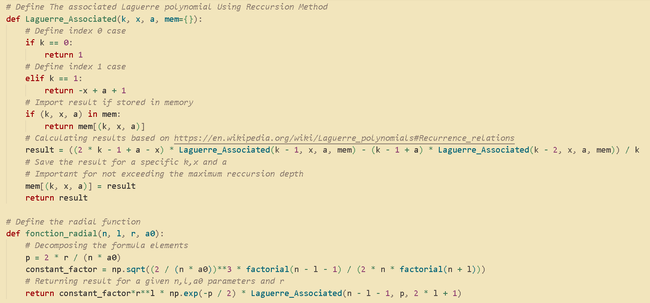

* **ANGULAR PART OF THE SCHRODINGER EQUATION**

The angular function is described by spherical harmonics and is a function of the polar angle 𝜃 and the azimuthal angle 𝜑. The angular function gives the shape and orientation of the atomic orbital. It depends on two parameters which are m (magnetic quantum number) and l (azimuthal quantum number) and is defined as below: $$Y_{l}^{m}\left(θ,φ\right)={\left(-1\right)}^{m}\sqrt{\frac{\left(2l+1\right)\left(l-m\right)!}{4π \left(l+m\right)!}}P_{l}^{m}(cosθ)e^{imφ}$$

The module numpy was used to introduce the complex number $i$ into the equation.

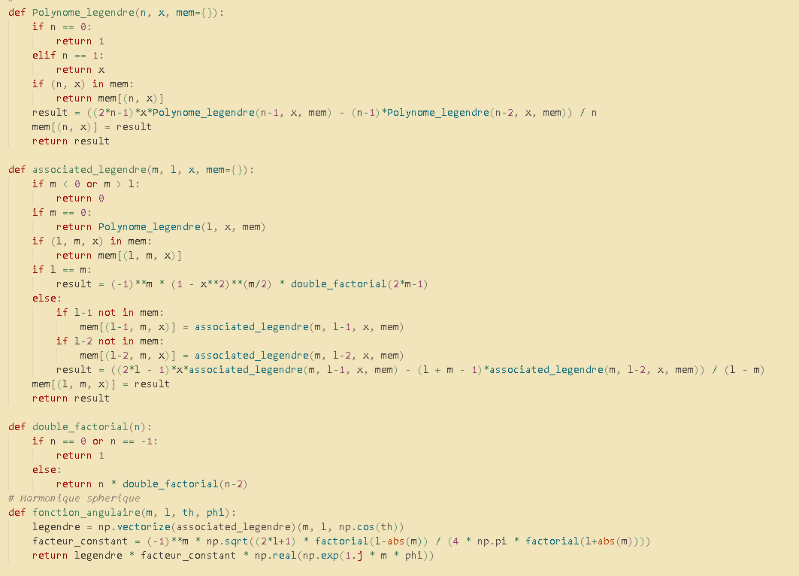

* **PLOTING AND VISUALIZATION**

The module matplotlib was used to plot the radial function in the 2D plane and the spherical harmonics in 3D space using conversion methods from spherical base coordinates to Cartesian (x,y,z) coordinates

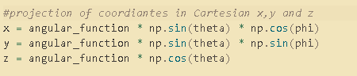

And finally figures were created to fit both plots on the same window:

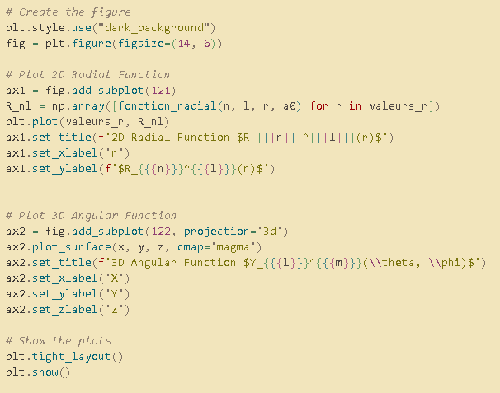

* **FUTURE PLANS AND INTENTIONS FOR THE PROJECT**

.The project eventually aims towards finalizing the visualization of the $ψ_{nlm}(r,θ,φ)$ function and implementing the code on a better performing programming language and at a lower level of memory control to ensure an optimized solution.

.Empowering my coding abilities and mathematical understanding of quantum phenomenon and possibly tackling subjects like quantum computing and qubit simulation.

.Learning to use “git” and sharing projects for online contributions and validation from much skilled programmers around the world.

.Building a rich portfolio of varying projects and subjects.

* Source code and executables are again available for trial and inspection   
   author : Moomen Al Ferchichi